

DEPARTMENT OF BIOMEDICAL ENGINEERING

NOISE POLLUTION MONITORING

PHASE 3 DOCUMENT SUBMISSION

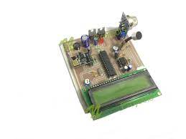

TEAM MEMBERS:

P.THAMARAISELVI -732721121056

M.SHARMILA -732721121045

S.SOWMIYA - 732721121050

D.DHARSHSHINI -732721121012

M.MENAKA -732721121027

**INTRODUCTION:**

Noise pollution monitoring is a crucial aspect of environmental management aimed at assessing and controlling the levels of unwanted or harmful sounds in a given area. It involves the systematic collection, analysis, and interpretation of data related to the intensity, frequency, and duration of noise in specific locations. This process helps in understanding the impact of noise pollution on the environment, human health, and overall quality of life.Methods of noise pollution monitoring include the use of specialized equipment such as sound level meters and noise dosimeters. These devices measure various parameters of sound, including decibel levels, frequency spectrum, and duration of exposure.Continuous monitoring stations are often strategically placed in urban centers, industrial zones, and other areas of interest to gather comprehensive data over time. Additionally, mobile monitoring units can be deployed to assess noise levels in specific locations or during events.

Advancements in technology have also enabled the development of sophisticated software applications that can process and analyze large volumes of noise data, allowing for more precise assessments and better-informed decision-making.

**BLOCK DIAGRAM:**

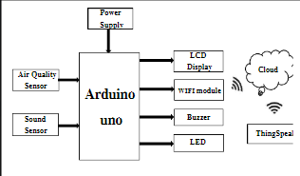

**ARDUINO UNO:**

Arduino UNO is a low-cost, flexible, and easy-to-use programmable open-source microcontroller board that can be integrated into a variety of electronic projects. This board can be interfaced with other Arduino boards, Arduino shields, Raspberry Pi boards and can control relays, LEDs, servos, and motors as an output.

**LCD DISPLAY:**

LCDs are commonly used for portable electronic games, as viewfinders for digital cameras and camcorders, in video projection systems, for electronic billboards, as monitors for computers, and in flat-panel televisions.

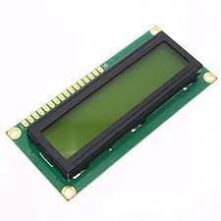

**WIFI MODULE:**

Wifi modules or wifi microcontrollers are used to send and recieve data over Wi-Fi. They can also accept commands over the Wi-Fi. Wi-Fi modules are used for communications bewtween devices. They are most commonly used in the field of Internet of Things.

**BUZZER:**

A buzzer or beeper is an audio signaling device, which may be mechanical, electromechanical, or piezoelectric (piezo for short). Typical uses of buzzers and beepers include alarm devices, timers, train and confirmation of user input such as a mouse click or keystroke.

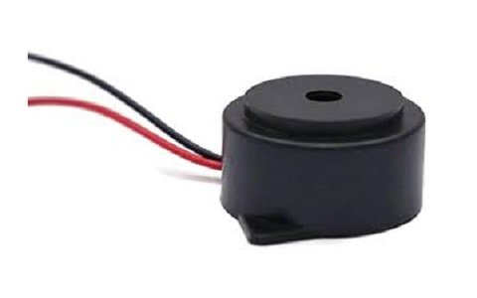

**LED:**

The high efficiency and directional nature of LEDs makes them ideal for many industrial uses. LEDs are increasingly common in street lights, parking garage lighting, walkway and other outdoor area lighting, refrigerated case lighting, modular lighting, and task lighting.

**SOUND SENSOR:**

The sound sensor is one type of module used to notice the sound. Generally, this module is used to detect the intensity of sound. The applications of this module mainly include switch, security, as well as monitoring. The accuracy of this sensor can be changed for the ease of usage.

**NECESSARY STEPS TO FOLLOW IN NOISE POLLUTION MONITORING**:

Define Objectives and Scope:

Clearly define the purpose of the monitoring, whether it's for compliance with regulations, assessing impact on communities or ecosystems, or other specific goals.

Determine the geographical scope, including specific locations, boundaries, and timeframes.

Select Monitoring Sites:

Identify and choose monitoring sites strategically. Consider proximity to noise sources, land use, and presence of receptors (e.g., residents, wildlife).

Ensure sites represent a variety of scenarios (e.g., industrial areas, residential zones, natural habitats).

Acquire Suitable Equipment:

Obtain appropriate noise monitoring equipment, such as sound level meters, noise dosimeters, or environmental noise monitoring stations.

Ensure the equipment is calibrated and well-maintained to ensure accurate measurements.

Data Collection:

Deploy monitoring equipment at selected sites and record noise levels over specified time periods.

Decide whether data collection will be continuous or periodic, based on monitoring Objectives.Data Analysis:

Analyze collected data to assess noise levels, including peak levels, average levels, and other relevant parameters.

Utilize specialized software for data processing and interpretation.

Interpretation and Reporting:

Interpret data in the context of monitoring objectives, regulations, and standards.

Prepare comprehensive reports with findings, analysis, and recommendations. Ensure reports are accessible to stakeholders, regulators, and the public.

Compliance Assessment:

Determine if recorded noise levels comply with local, regional, and national noise regulations and standards.

If violations are identified, recommend and implement appropriate actions and mitigation measures.

Public Engagement and Communication:

Engage with the community and stakeholders to share findings, gather feedback, and address concerns.

Clearly communicate results and potential implications for community health and well-being.

Long-Term Monitoring and Trend Analysis:

Consider implementing long-term monitoring to observe trends in noise levels over time.

Analyze trends to identify potential changes in noise pollution and inform future mitigation efforts.

Mitigation and Management:

If excessive noise levels are identified, develop and implement effective mitigation strategies.

Monitor the effectiveness of mitigation measures and adjust as needed.

Record Keeping and Documentation:

Maintain detailed records of monitoring activities, including equipment calibration, data collection, analysis, and reports.

Proper documentation helps ensure transparency and accountability.

By following these steps, noise pollution monitoring can provide valuable insights for decision-making, policy development, and the protection of both human health and the environment.Engage with the community and stakeholders to share findings, gather feedback, and address concerns.

**DATA SET:**

In noise pollution monitoring, a dataset is a collection of structured information gathered from various monitoring points. This dataset serves as the foundation for analysis, interpretation, and reporting of noise levels. Here's a breakdown of noise pollution monitoring dataset might include:

Location Information:

Latitude and Longitude Coordinates:

Precise geographical coordinates of the monitoring site.

Site Name or Identifier:

A label for easy identification of the monitoring location (e.g., "Industrial Area A" or "Residential Zone B").

Time and Date Stamp:

Date:

The specific date of the monitoring.

Time:

The time when noise measurements were taken.

Noise Parameters:

L_eq (Equivalent Continuous Noise Level):

A single value representing the continuous equivalent noise level over a defined period.

L_max (Maximum Noise Level):

The highest instantaneous noise level recorded during the monitoring period.

L_min (Minimum Noise Level):

The lowest instantaneous noise level recorded during the monitoring period.

L10, L50, L90, etc.: Percentile levels representing the noise levels exceeded for 10%, 50%, 90%, etc. of the monitoring period.

Frequency Spectrum:

If available, information about noise levels at specific frequency bands (e.g., octave or third-octave bands).

Duration of Measurement:

The duration of each measurement period (e.g., 1-hour L_eq, 15-minute L_eq).

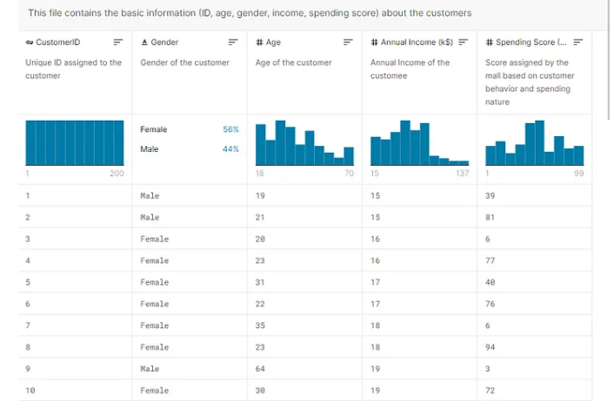

Source Information:

Description of nearby noise sources (e.g., road traffic, industrial machinery, recreational events).

Weather Conditions:

Temperature, humidity, wind speed, and direction. Weather conditions can affect sound propagation.

Site Characteristics:

Description of the monitoring site (e.g., urban, rural, indoor, outdoor).

Surrounding land use (e.g., residential, commercial, industrial, natural).

Instrument Details:

Make and model of the monitoring equipment used.

Calibration information and maintenance records.

Regulatory Standards:

Relevant local, regional, or national noise regulations and standards.

**CHALLENGES INVOLVED IN LOADING AND PREPROCESSING IN NOISE POLLUTION MONITORING:**

Loading and preprocessing data in noise pollution monitoring can present various challenges, especially due to the complexity and diversity of the data sources. Here are some common challenges faced in this process**:**

Data Volume and Storage:

Large Datasets:

Noise monitoring can generate a significant volume of data, especially if monitoring is continuous or covers extensive periods. Handling and storing such large datasets can strain computational resources.

Data Quality and Accuracy:

Sensor Calibration:

Ensuring that monitoring equipment is properly calibrated is crucial for accurate measurements. Inaccurate or poorly calibrated sensors can lead to skewed results.

Data Synchronization:

Time Synchronization:

When using multiple monitoring devices, ensuring that the data collected is properly synchronized in terms of time can be challenging. Misaligned timestamps can lead to inaccurate analysis.

Missing or Corrupted Data:

Data Gaps:

Equipment malfunction, power outages, or other issues may lead to missing data points. Addressing these gaps while maintaining data integrity is a challenge.

Data Formats and Compatibility:

Diverse Data Sources:

Data may come from various types of monitoring equipment, each potentially producing data in different formats. Ensuring compatibility for seamless integration is essential.

Noise from Non-Target Sources:

Background Noise:

Filtering out noise from non-target sources (e.g., natural environmental sounds) can be challenging, particularly in outdoor monitoring scenarios.

Outliers and Anomalies:

Noise Events:

Identifying and handling outlier events (e.g., sudden loud noises, transient spikes) is crucial for accurate data interpretation. These events may need special attention during preprocessing.

Spatial Variability:

Site-specific Characteristics:

Different monitoring sites may have unique characteristics (e.g., natural topography, urban density) that impact noise levels. Accounting for these variations in preprocessing can be complex.

Environmental Conditions:

Weather Effects:

Weather conditions (e.g., wind speed, humidity) can affect noise propagation and intensity. Incorporating weather data into the preprocessing steps may be necessary.

Regulatory Compliance and Standards:

Adherence to Standards:

Ensuring that the data meets regulatory standards and complies with specific monitoring protocols can be challenging, especially if standards change over time.

Data Privacy and Security:

Sensitive Locations:

In some cases, monitoring may occur in areas where privacy concerns are paramount. Proper handling and anonymization of data may be required.

Data Documentation and Metadata:

Meta-information:

Capturing and maintaining metadata (information about the data) is important for ensuring transparency, reproducibility, and quality control.

**HOW TO OVERCOME THE CHALLENGES OF LOADING AND PREPROCESSING IN NOISE POLLUTION:**

Overcoming the challenges of loading and preprocessing data in noise pollution monitoring requires careful planning, use of appropriate tools and techniques, and adherence to best practices. Here are strategies to address these challenges:

Data Volume and Storage:

Employ Data Compression:

Use compression techniques to reduce the storage requirements for large datasets without compromising data integrity.

Data Quality and Accuracy:

Regular Calibration:

Ensure monitoring equipment is regularly calibrated and maintained to guarantee accurate measurements.

Data Synchronization:

Use Synchronized Clocks:

Ensure all monitoring devices have synchronized clocks to prevent issues with misaligned timestamps.

Missing or Corrupted Data:

Implement Data Recovery Protocols:

Have protocols in place to address data gaps, such as using interpolation or backup systems.

Data Formats and Compatibility:

Standardize Data Formats:

Convert data from diverse sources into a standardized format for seamless integration and analysis.

Noise from Non-Target Sources:

Employ Noise Filtering Algorithms:

Use advanced algorithms to filter out background noise from non-target sources.

Outliers and Anomalies:

Develop Outlier Detection Methods:

Implement algorithms to automatically detect and handle outlier events.

Spatial Variability:

Incorporate Site Characteristics:

Factor in unique site characteristics during data analysis and interpretation.

Environmental Conditions:

Integrate Weather Data:

Include weather data in the preprocessing steps to account for its impact on noise propagation.

Regulatory Compliance and Standards:

Stay Informed:

Keep abreast of any changes in noise pollution regulations and standards to ensure compliance.

Data Privacy and Security:

Implement Privacy Protocols:

If monitoring in sensitive locations, establish protocols to handle data securely and ensure privacy.

Data Documentation and Metadata:

Maintain Detailed Records:

Keep thorough documentation and metadata to provide context and ensure transparency.

**PREPROCESSING OF DATA SET:**

#include <Wire.h>

#include <Adafruit_Sensor.h>

#include <Adafruit_BME280.h>

#include <SoftwareSerial.h>

SoftwareSerial mySerial(2, 3); // RX, TX

Adafruit_BME280 bme;

void setup() {

Serial.begin(9600);

mySerial.begin(9600);

if (!bme.begin(0x76)) {

Serial.println("Could not find a valid BME280 sensor, check wiring!");

while (1);

}

}

void loop() {

delay(2000);

float temperature = bme.readTemperature();

float humidity = bme.readHumidity();

float pressure = bme.readPressure() / 100.0F;

// Data preprocessing steps

float noise_level = calculateNoiseLevel(); // Placeholder function, replace with actual noise level calculation

// Transmit preprocessed data

mySerial.print(temperature);

mySerial.print(",");

mySerial.print(humidity);

mySerial.print(",");

mySerial.print(pressure);

mySerial.print(",");

mySerial.println(noise_level);

}

float calculateNoiseLevel() {

// Placeholder function, replace with actual noise level calculation

// This function should return the calculated noise level

return 75.0; // Example value

}

**OUTPUT:**

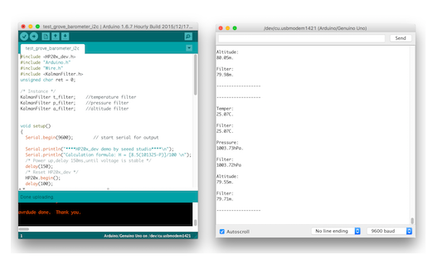

**LOADING DATASET:**

# Assuming the dataset is in a CSV file named 'noise_data.csv'

import pandas as pd

# Load the dataset into a DataFrame

df = pd.read_csv('noise_data.csv')

# Display the first few rows of the dataset

print(df.head())

**OUTPUT:**

**Location Date Time Noise_Level_dB**

**0 Site A 2021-10-01 08:00:00 70**

**1 Site A 2021-10-01 08:15:00 72**

**2 Site A 2021-10-01 08:30:00 75**

**3 Site A 2021-10-01 08:45:00 78**

**CONCLUSION:**

In conclusion, noise pollution monitoring plays a crucial role in understanding, managing, and mitigating the impacts of excessive noise on both the environment and human health. By employing accurate measurement techniques and leveraging technological advancements, we can work towards creating healthier and more sustainable living environments for all.